Το Εθνικό Μετσόβιο Πολυτεχνείο, το Πολυτεχνείο Κρήτης και οι Πολυτεχνικές Σχολές της χώρας, κατόπιν συνεννόησης των Πρυτάνεων και των Κοσμητόρων τους, προσκαλούν τα μέλη των αντίστοιχων κοινοτήτων να παρακολουθήσουν την ακόλουθη ομιλία, που διοργανώνεται με πρωτοβουλία του ΕΜΠ

Διαδικτυακή Ομιλία - Webinar
Engineering a Better World for All Humanity
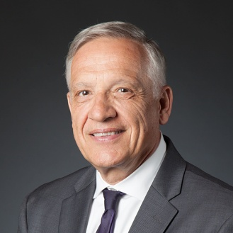
Yannis C. Yortsos*
Dean, Viterbi School of Engineering
University of Southern California, USA

Δευτέρα, 14 Φεβρουαρίου 2022, 5.00 μμ

Zoom Webinar: https://grnet.zoom.us/j/65674249982
NTUA youtube channel: https://www.youtube.com/channel/UC-L-24Fk5qakf_TxDadKH8g (live)

Abstract: Engineering and technology are driving discovery and innovation in practically all disciplines at an unprecedented pace, one that is certain to accelerate even further with advances in computing of all types, and the increasing relevance of AI and data sciences. Outstanding technical competence is needed to keep driving this transformation - we have termed this as the need to hug the exponential. In the constant and inexorable intertwining of the interface of technology with society, humanity, and the living environment, engineering has become the enabling discipline for solving grand-challenge-like problems, including increasingly human-centric ones. This engineering + mindset is permeating a vast variety of disciplines and areas, creating particularly fertile grounds for collaboration and innovation across the sciences, the professions and the arts.
At the same time, choosing what problems to focus to solve is an ethical decision. This means that as we educate the engineers, innovators and technologists of tomorrow, we should also help them with the building of character, shaped by a deep understanding of the human nature, ethics, and the impact, intended and unintended of engineering and technology to society, humanity and the living environment. In all these endeavors, with deep technological and human dimensions, we need to constantly re-invent, innovate and lead. Together, competence and character spell trust, and the creation of trustworthy engineers, more urgently needed today than ever before.
This webinar addresses key, salient features of these ideas and their relevance to engineering education and research. In particular it focuses on the development of the associated mindsets for our undergraduate engineering students, as articulated in the Grand Challenges Scholars Program, which aims at the creation of such engineering graduates.

* Recipient of Bernard M. Gordon Prize 2022, of the National Academy of Engineering (NAE): “…For creating an innovative education program that prepares students to become future engineering leaders who will address the NAE Grand Challenges of Engineering”.

